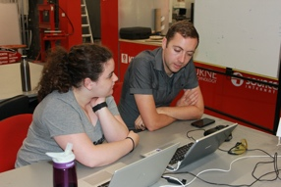 | IFIP Working Group 3.3  Research into Educational Applications of Information Technologies
Monthly Member template for publication on http://www.ifipwg3-3.org/
Member title (ie/ Professor/Dr)
Member name
Member university
Member email
Member Photograph

Title of Paper
Name of Journal or Book published
Date of publication
Maximum 150 words describing paper/project & outcomes/recommendations
Citation in APA format
URL for further information

If there are pictures from the project, email these across, however please ensure that all copyright has been cleared to use these pictures.
Completed forms to be sent to Therese: tkeane@swin.edu.au

